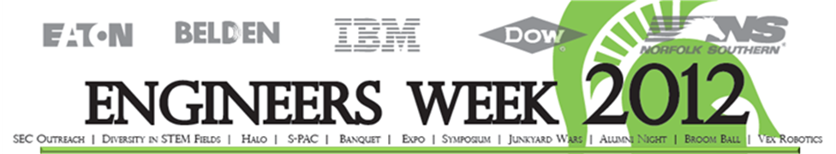COMPANIES RECRUITING COMPUTER SCIENCE ENGINEERING

Agate Software, Inc.
Alcoa, Inc.
American Axle & Manufacturing
ArcelorMittal
Barracuda Networks
BMW Manufacturing Co.
Behr America, Inc.
Blue Cross Blue Shield of Michigan
Bosch
Capgemini
Caterpillar Inc
Cengage Learning
Compuware Corporation
Consumers Energy
Crowe Horwath LLP
Delta Dental of Michigan, Ohio, and Indiana
Epic
ePrize
Fast Enterprises, LLC
Ford Motor Company
Gentex Corporation
Glyph
Harman International
IBM
Jackson National Life Insurance
Leightronix, Inc.
Michigan State University
Microsoft Corporation
New World Systems
Norfolk Southern Corporation
Perrigo
Plex Systems
Pyramid Solutions, Inc.
Rapid Global Bussiness Solutions
Recsolu
Siemens Corporation
Sparrow Health System
Tata Consultancy Services
TechSmith Corporation
Thomson Reuters
Vertafore
Union Pacific Railroad
United States Steel (MI)
Urban Science
Wolverine Trading LLC
Pi Innovo
Teoresi, Inc.

Recruiting Recruiting All Majors
A123 Systems
Accuride Corporation
Aerotek
Auto-Owners Insurance Company
Bridgestone Americas
Nestle USA
Board of Water & Light
Continental Automotive Systems
Dow Chemical Company
Emergent Systems
General Electric
Hyundai America Technical Center, Inc
Inteva Products
Johnson Controls
Kiewit Infrastructure Co.
Herman Miller, Inc.
Leightronix, Inc.
LeMatic, Inc.
LLamasoft, Inc.
MSU MBA Program
Magna Powertrain
Michigan Dairy
Nestle USA
Peace Corps
Procter & Gamble
Rapid Global Bussiness Solutions
ROWE Professional Services Company
Secure 24
Severstal North America
Schneider Electric
The Engineering Society of Detroit
The Hershey Company
West Monroe Partners
Wolfram
US Postal Service
U.S. Navy

